**D1 – Evaluate the use of e-commerce in a ‘brick and click’ organisation**

**Introduction**

In this report, I will evaluate the e-commerce site, ‘brick and click’. I will explain what the ‘brick’ and ‘click’ organisation are with the advantages and disadvantages of becoming e-commerce. I will provide evidence for the business going to profit from a Brick organisation to a Brick and Click. Finally, a conclusion would be provided.

**Brick & Click**

Brick & Click are types of organisations. Brick is a type of organisation that have land-based offices and Click is online offices. Merging them together manage both offline and online operations. This provides better services for the customers. Many current organisations are using this strategy.

**Amazon –** Pure Click

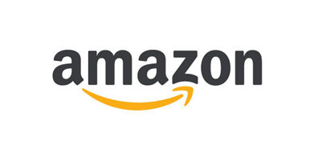As you may know, Amazon is an e-commerce website that provides good and services only through the web. Transactions and payments are complete through debit cards. You cannot go to an Amazon store, because it is purely online. I can order a book of Amazon by creating an account with them and ordering the book. The book will come in around 3-5 working days. This is how the process works.

**PC World –** Brick and Click

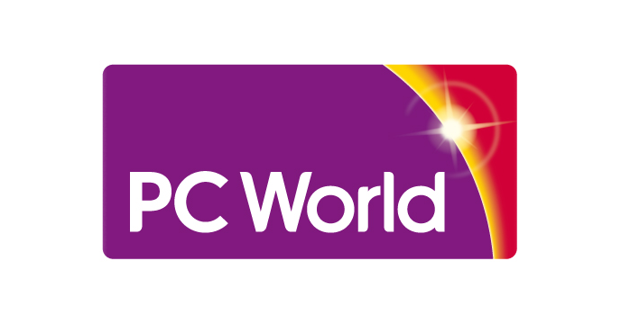PC World however provide both online material and store based. This is a benefit for any customer, because if they want to get something that they want, they can find the information in store and order it online. Both ways are necessary. These ways benefits the company by income is coming in both ways.

**Advantages**

* Low cost to start off

Low cost is always an advantage for the company. This is considering how much income is coming in to the company. A low start off cost for an e-commerce website is low compared to a store.

* Low maintenance

Low maintenance cost is always important too. This is the same with low cost to start. If Tick Tock were to maintain a website, it would be cheap.

* Trading 24/7

Depending on how long you trade with customers is very important. A pure click organisation allows it to do so. This means customers gain access to how long they want to trade for.

* Cover world-wide customers and cheap deals

The company can reach out to the whole world. Most people across the world use the internet and customers can gain access to the website easily. In addition, most customers like to get cheap deals. The internet certainly allows the customers to do that.

**Disadvantages**

* IT staff required

IT staff is required for their knowledge for the website design and maintaining. The IT staff that are required need to be paid too. It takes time to sort all of the stuff out with the right equipment needed to do this too.

* World-wide competitors

Worldwide competitors are competing if Tick Tock were to use this idea. The struggle is that they would need a competitive advantage over all these competitors. No matter how many stores they are online, worldwide, people need to choose Tick Tock.

* Delivery issues

Delivery issues could be very dangerous to deal with, because if any item is damaged on the way; the user would not want to use it. They would need a refund, and this is resulting in the customer being unhappy. In addition, the problem could be that if the product is delayed. This makes the customer unhappy too.

* Security costs

Security costs for the website and the data that is stored needs to be protected. If any hacker was to gain access with these details, they could be using it in the wrong way. The company could be blamed for lack of protection. This could result in image brand and customer(s) unhappy.

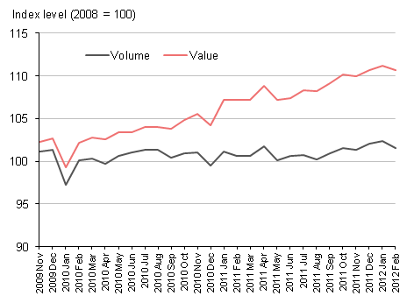**Statistic**

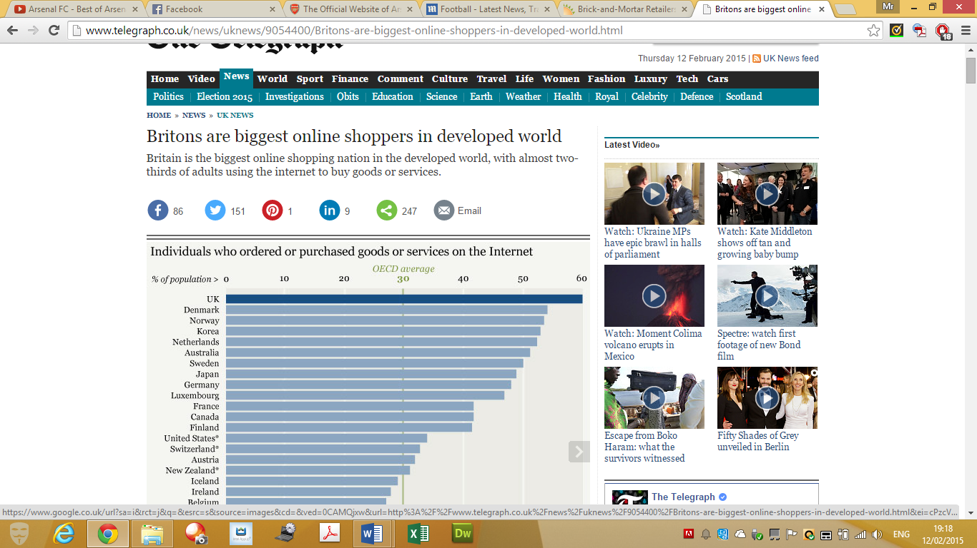

These statistics show that both of them are competitive. These statistics show that both of the type of organisations are rising. This shows how sales within both sectors have developed. This could benefit the organisations such as PC World. The company could grow big, not only nationally, but also internationally.

**Conclusion**

I personally think that Tick Tock should become Brick and Click. I will require hard work with IT staff monitoring online sales and many other jobs. However, the outcome is very rewarding. People get to know your business from around the world. For example, PC world shown above. They get sales online and from store. Either way, customers are satisfied.

**Reference**

<http://www.telegraph.co.uk/news/uknews/9054400/Britons-are-biggest-online-shoppers-in-developed-world.html>

<http://www.ons.gov.uk/ons/resources/feb2012allforsupanalysis_tcm77-261345.png>